

IRF21/3224

Gateway determination report – PP-2021-4964

Rezone Council Public Reserves at Retford Park, Bowral and Anembo Street, Moss Vale to RE1 Public Recreation

August 21

Published by NSW Department of Planning, Industry and Environment

[dpie.nsw.gov.au](http://www.dpie.nsw.gov.au/)

Title: Gateway determination report – PP-2021-4964

Subtitle: Rezone Council Public Reserves at Retford Park, Bowral and Anembo Street, Moss Vale to RE1 Public Recreation

© State of New South Wales through Department of Planning, Industry and Environment 2021. You may copy, distribute, display, download and otherwise freely deal with this publication for any purpose, provided that you attribute the Department of Planning, Industry and Environment as the owner. However, you must obtain permission if you wish to charge others for access to the publication (other than at cost); include the publication in advertising or a product for sale; modify the publication; or republish the publication on a website. You may freely link to the publication on a departmental website.  
  
Disclaimer: The information contained in this publication is based on knowledge and understanding at the time of writing (August 21) and may not be accurate, current or complete. The State of New South Wales (including the NSW Department of Planning, Industry and Environment), the author and the publisher take no responsibility, and will accept no liability, for the accuracy, currency, reliability or correctness of any information included in the document (including material provided by third parties). Readers should make their own inquiries and rely on their own advice when making decisions related to material contained in this publication.

Contents

1 Planning proposal 1

1.1 Overview 1

1.2 Objectives of planning proposal 1

1.3 Explanation of provisions 1

1.4 Site description and surrounding area 2

1.5 Mapping 3

2 Need for the planning proposal 3

3 Strategic assessment 3

3.1 Regional Plan 3

3.2 Local 3

3.3 Section 9.1 Ministerial Directions 4

3.4 State environmental planning policies (SEPPs) 4

4 Site-specific assessment 4

4.1 Environmental 4

4.2 Social and economic 4

5 Consultation 5

5.1 Community 5

5.2 Agencies 5

6 Timeframe 5

7 Local plan-making authority 5

8 Assessment summary 5

9 Recommendation 5

Table 1 Reports and plans supporting the proposal

| Relevant reports and plans |
| --- |
| Planning Proposal – Version 1 – August 2021 |
| Council Report – 14 July 2021 |
| Council Resolution – 14 July 2021 |
| Site map – Retford Park, Bowral |
| Site map – Anembo Street, Moss Vale |

# Planning proposal

## Overview

Table 2 Planning proposal details

| LGA | Wingecarribee |
| --- | --- |
| **PPA** | **Wingecarribee Shire Council** |
| **NAME** | **Retford Park and Anembo Street Public Reserve Rezonings** |
| **NUMBER** | **PP-2021-4964** |
| **LEP TO BE AMENDED** | **Wingecarribee Local Environmental Plan 2010** |
| **ADDRESS** | **Retford Park, Bowral and Anembo Street, Moss Vale** |
| **DESCRIPTION** | **Lot 439 DP 1248107 (Retford Park) and Lot 1266 DP 1248764 (Anembo Street)** |
| **RECEIVED** | **11/08/2021** |
| **FILE NO.** | **IRF21/3224** |
| **POLITICAL DONATIONS** | **There are no donations or gifts to disclose and a political donation disclosure is not required** |
| **LOBBYIST CODE OF CONDUCT** | **There have been no meetings or communications with registered lobbyists with respect to this proposal** |

## Objectives of planning proposal

The planning proposal contains objectives and intended outcomes that adequately explain the intent of the proposal.

The objectives of the planning proposal are to:

* rezone two sites at Retford Park, Bowral and Anembo Street, Moss Vale from R2 Low Density Residential to RE1 Public Recreation and remove minimum lot size controls to better reflect their use as Council-owned public reserves.

The objectives of this planning proposal are clear and adequate.

## Explanation of provisions

To achieve the intended outcomes, the planning proposal seeks to amend the Wingecarribee LEP 2010 by:

* rezoning the two sites (land at Retford Park, Bowral - Lot 439 DP 1248107 and Anembo

Street, Moss Vale - Lot 1266 DP 1248764) to RE1 Public Recreation;

* removing the current minimum lot size controls applying to these sites; and
* amending the relevant Land Zoning and Lots Size maps.

## Site description and surrounding area

The planning proposal applies to two different public reserves in the Wingecarribee local government area as follows:

Site 1 – Retford Park West, Bowral (Lot 439 DP 1248107)

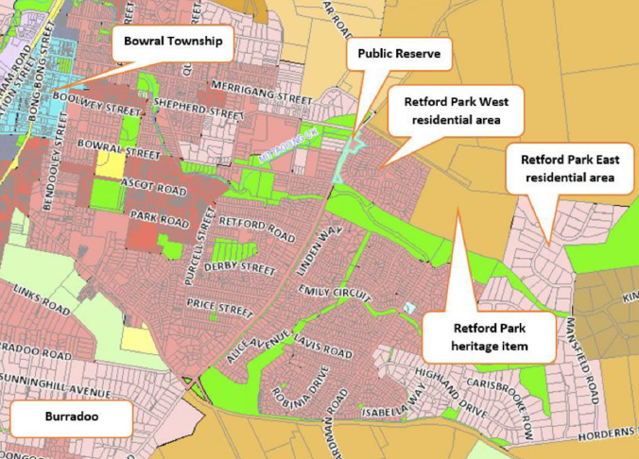

Figure Site 1 – Retford Park, Bowral (source: Planning Proposal)

Site 1 – Anembo Street, Moss Vale (Lot 1266 DP 1248764)

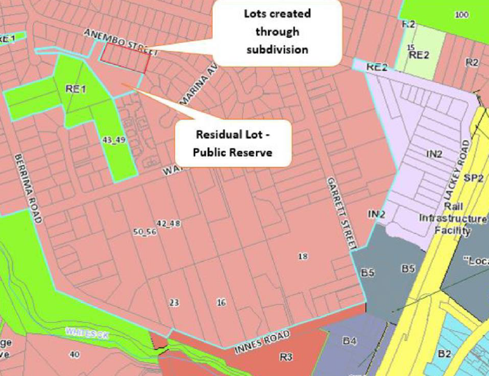

Figure 2 Site 2 – Anembo Street, Moss Vale (source: Planning Proposal)

Both sites are public reserves owned by Council dedicated because of previous residential subdivisions. The planning proposal would rezone the sites to better reflect their use.

## Mapping

The planning proposal will require amendment to the relevant Land Zoning and Lot Size maps. Draft maps are not included in the planning proposal.

A Gateway condition is recommended requiring these maps to be included in the exhibited planning proposal.

# Need for the planning proposal

The planning proposal is needed to ensure an appropriate zoning to reflect the use of the sites as public open space into the future.

A planning proposal of this nature is considered the best means of achieving the intended outcomes.

# Strategic assessment

## Regional Plan

The following table provides an assessment of the planning proposal against relevant aspects of the South East and Tablelands Regional Plan.

Table 3 Regional Plan assessment

| Regional Plan Objectives | Justification |
| --- | --- |
| Goal 3 – Healthy and connected communities | The planning proposal is consistent with Goal 3 of the Regional Plan by promoting healthy and connected communities with easy access to recreational areas such as public open space. |

## Local

The proposal states that it is consistent with the following local plans and endorsed strategies. It is also consistent with the strategic direction and objectives, as stated in the table below:

Table 4 Local strategic planning assessment

| Local Strategies | Justification |
| --- | --- |
| Local Strategic Planning Statement | The planning proposal aligns with Planning Priority 6.3 in the LSPS, which outlines the importance of enhancing the liveability of the towns and villages throughout the Shire.  This is because the planning proposal supports community recreational spaces that promote ‘healthy, culturally rich and socially connected’ communities. |

## Section 9.1 Ministerial Directions

The planning proposal’s consistency with relevant section 9.1 Directions is discussed below:

Table 5 Section 9.1 Ministerial Direction assessment

| Directions | Consistent/ Not Applicable | Reasons for Consistency or Inconsistency |
| --- | --- | --- |
| Direction 3.1 – Residential Zones | No | Whilst the land is zoned R2 Low Density Residential, both sites have been set aside for use as public open space through previous subdivisions.  Therefore, no actual loss of land for housing would occur and any potential inconsistency with this Direction is considered minor. |
| Direction 4.4 - Planning for Bushfire Protection | No | The planning proposal is currently inconsistent with this Direction as consultation has not occurred with the NSW Rural Fire Service (RFS).  Whilst no adverse bushfire impacts are anticipated, consultation is required with the RFS under the terms of the Direction. Consistency with this Direction remains unresolved until this occurs. |
| Direction 5.2 – Sydney Drinking Water Catchment | No | The planning proposal is currently inconsistent with this Direction as consultation has not occurred with WaterNSW.  Whilst no adverse water impacts are anticipated, consultation is required with WaterNSW. Consistency with this Direction remains unresolved until this occurs. |

## State environmental planning policies (SEPPs)

The proposal is not inconsistent with relevant SEPPs.

# Site-specific assessment

## Environmental

The sites have been identified/retained as public reserves through previous subdivision and are unlikely to adversely impact upon critical habitat or threatened species, populations, or ecological communities.

No adverse environmental effects are anticipated because of the proposal.

## Social and economic

The proposal would have a positive social and/or economic impact by rezoning land for use a public open space which would contribute to the character and overall liveability Wingecarribee and provide public recreational spaces to benefit the community.

# Consultation

## Community

Council proposes a community consultation period of 28 days.

The exhibition period proposed is considered appropriate, and forms a part of the conditions of the Gateway determination.

## Agencies

It is recommended the following agencies be consulted on the planning proposal and given at least 21 days to comment:

* WaterNSW; and
* NSW Rural Fire Service.

# Timeframe

Council proposes a 4 month time frame to complete the LEP.

The Department recommends a time frame of 12 months in case any unforeseen issues arise.

A condition to the above effect is recommended in the Gateway determination.

# Local plan-making authority

Council has advised that it would like to exercise its functions as a Local Plan-Making authority.

As the planning proposal is minor and consistent with local and regional planning objectives, the Department recommends that Council be authorised to be the local plan-making authority for this proposal.

# Assessment summary

The planning proposal is supported to proceed with conditions as it is consistent with local and regional strategic planning objectives, would ensure zoning of the sites better reflects their use as pubic open space, and would result in positive social impacts by providing public recreational spaces to benefit the community.

# Recommendation

It is recommended the delegate of the Secretary:

* Agree that any inconsistencies with section 9.1 Direction 3.1 – Residential Zones is minor or justified; and
* Note that the consistency with section 9.1 Direction 4.4 – Planning for Bushfire Protection and Direction 5.2 – Sydney Drinking Water Catchment is unresolved and will require justification.

It is recommended the delegate of the Minister determine that the planning proposal should proceed subject to the following conditions:

1. Prior to public exhibition, the planning proposal is to be updated to include draft LEP Maps.
2. Consultation is required with the following public authorities:

* WaterNSW; and
* NSW Rural Fire Service.

1. The planning proposal should be made available for community consultation for a minimum of 28 days.
2. The timeframe for completing the LEP is to be 12 months from the date of the Gateway determination.
3. Given the nature of the proposal, Council should be authorised to be the local plan-making authority.

30/8/21

Graham Towers

Manager, Southern Region

31/08/2021

Sarah Lees

Director, Southern Region

Local and Regional Planning

Assessment officer

Andrew Hartcher

Senior Planner, Southern Region

Attachment A – Planning Proposal

Attachment B – Gateway determination

Attachment C – Letter to Council